1. <https://nodejs.org/en/>

Install nodejs

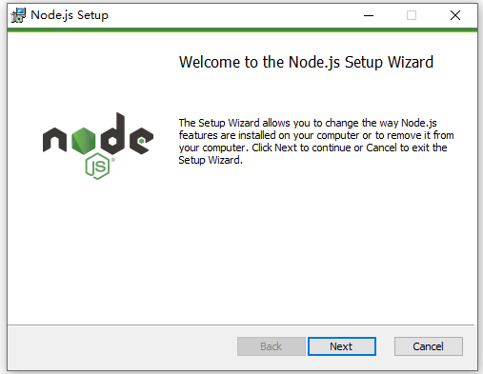

**Enter NPM in the terminal and this is successful**

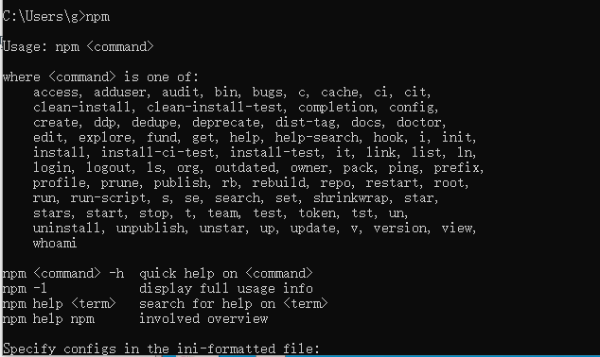

1. git clone <https://github.com/CS353-Team-7/DLMD.git>
2. cd .\DLMD\workspace\react-admin-client\

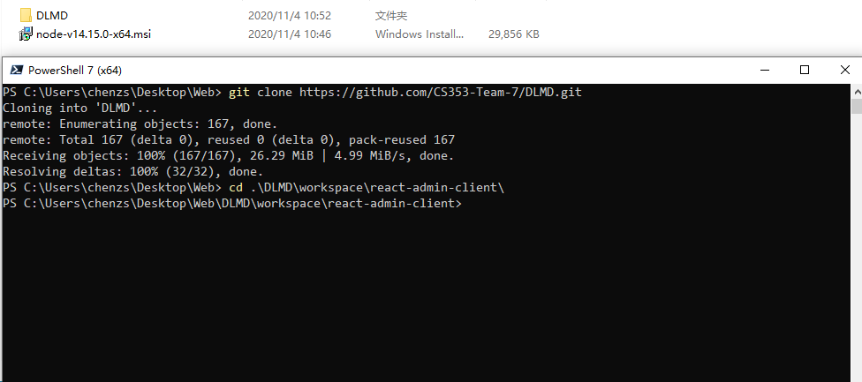

**4:Enter these commands if you receive the following error message**

**npm install react**

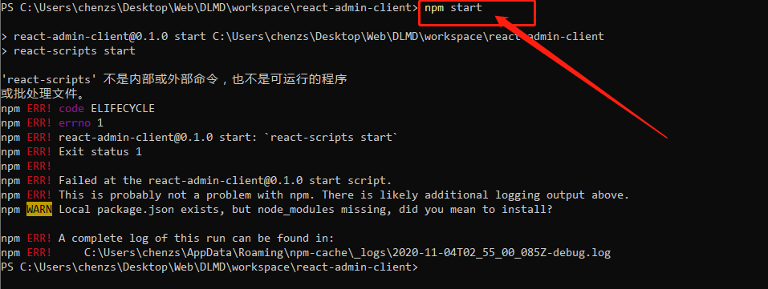

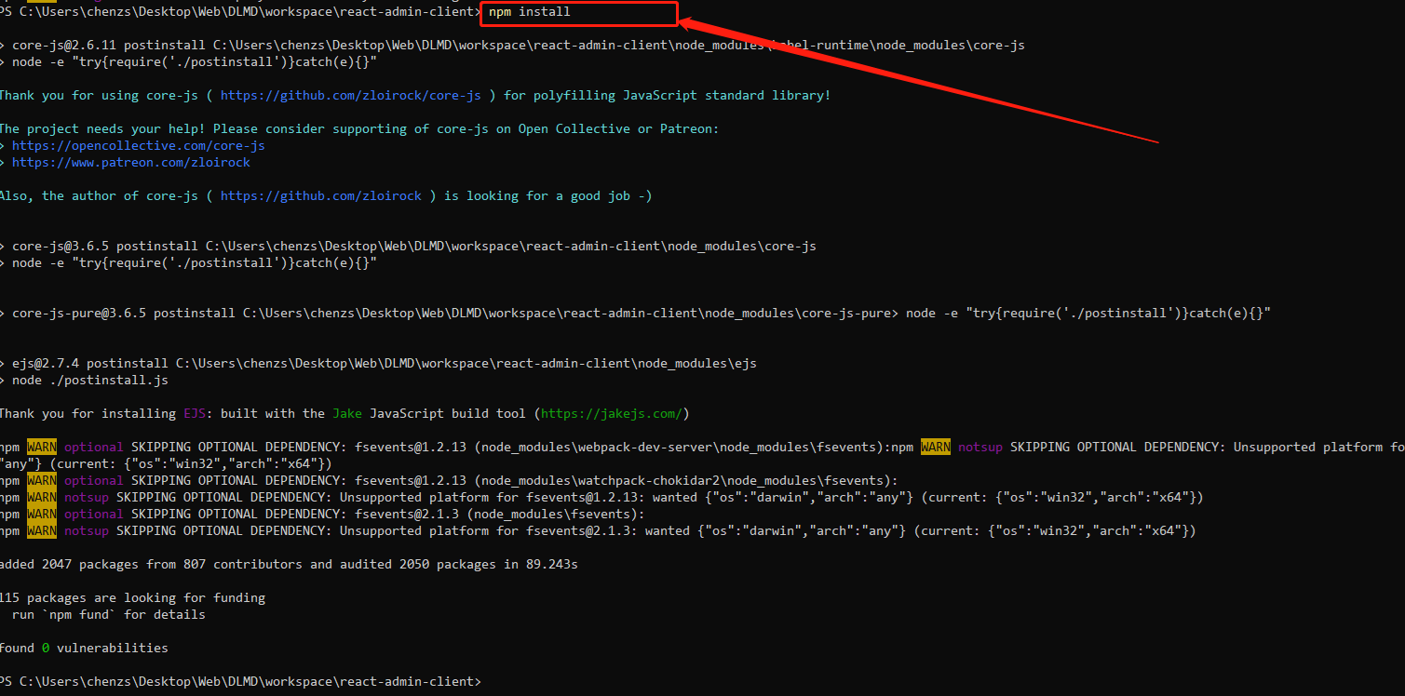

5:Npm start

Then wait for a minute

Use Chrome to access localhost:3000

